Assignment1 solution

Priority encoder

Design
The priority encoder design has two problems, syntax error (in the output port Y definition, type reg is missing) and a bug in the reset operation as the reset signal resets only the output Y and keeps the valid bit unchanged.
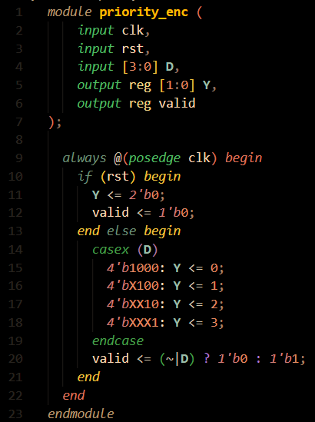
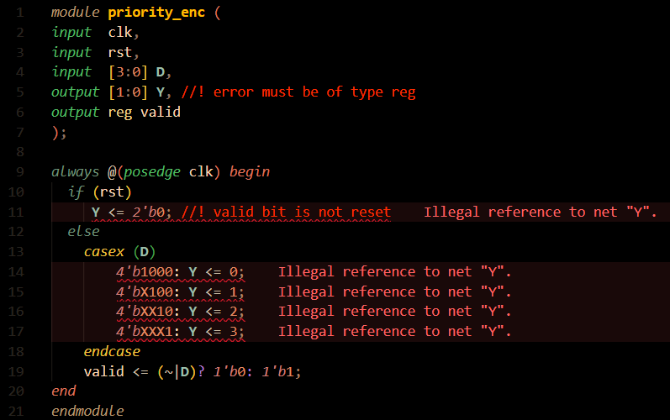
design before justifications

design after justifications

Verification plan

Testbench

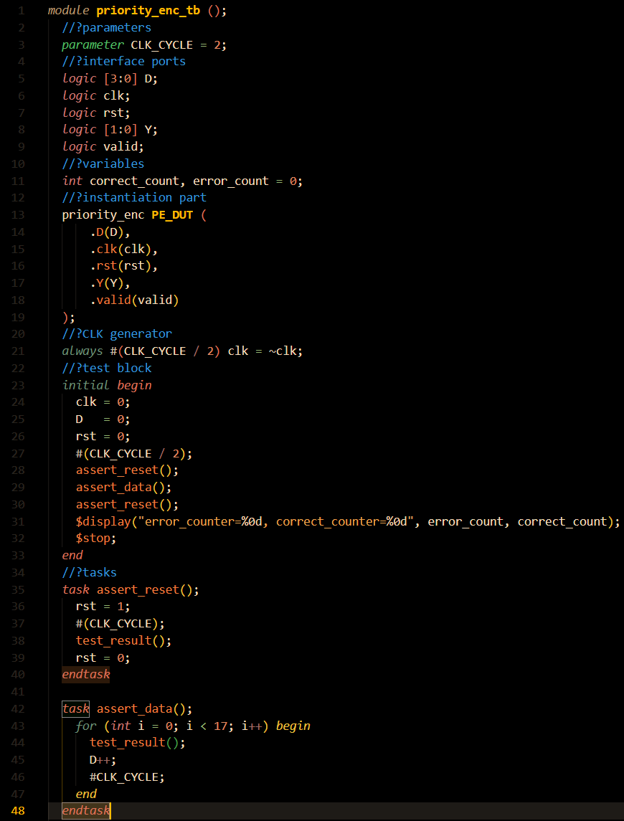

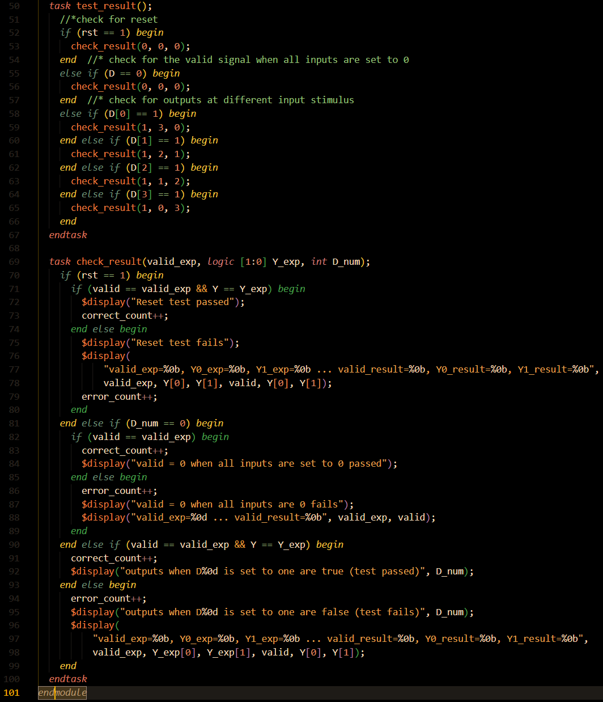
DO file

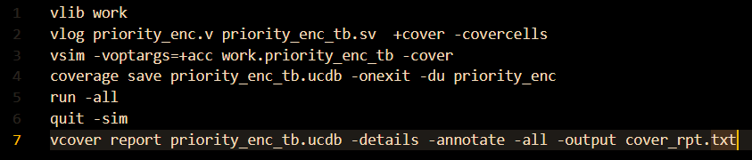
Simulation results

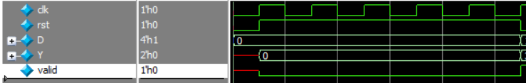
Encoder_1 test case:

Encoder_2 test case:
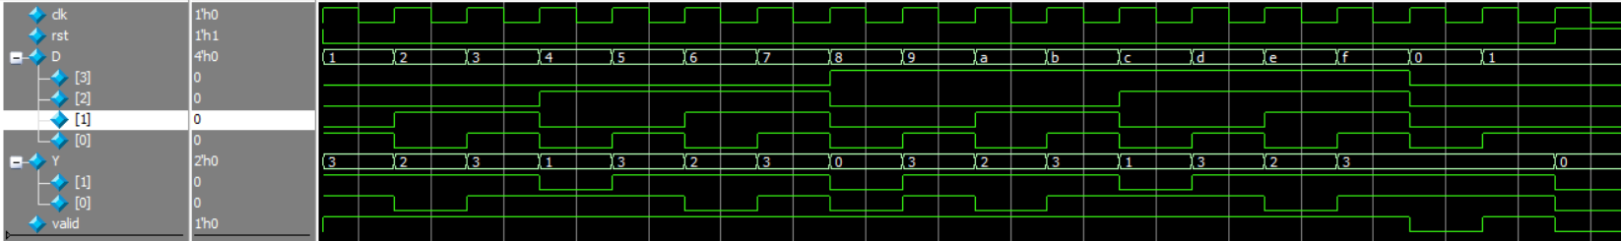

Coverage report

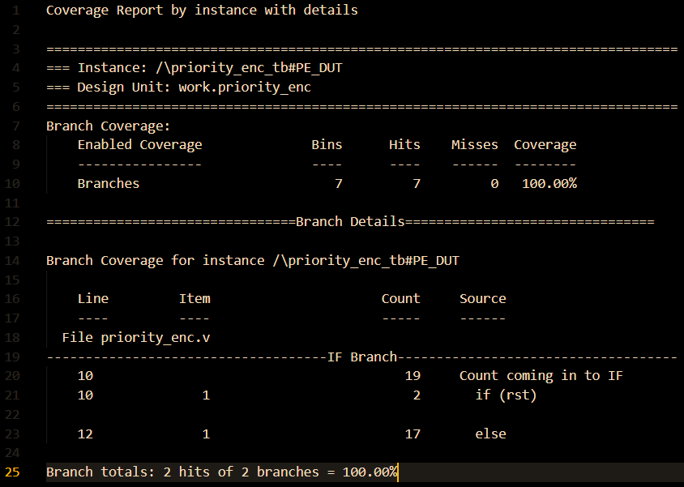
Branch coverage

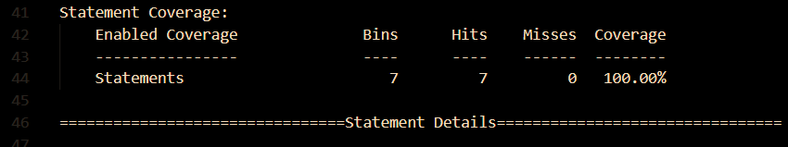
Statement coverage

Toggle coverage
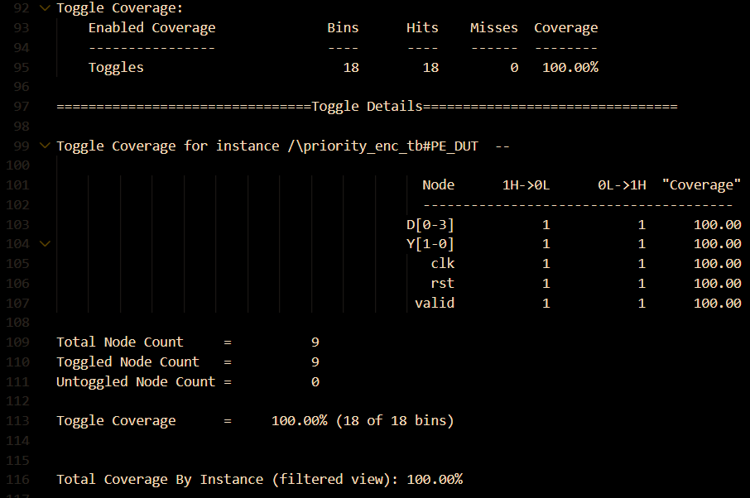

ALU

Design
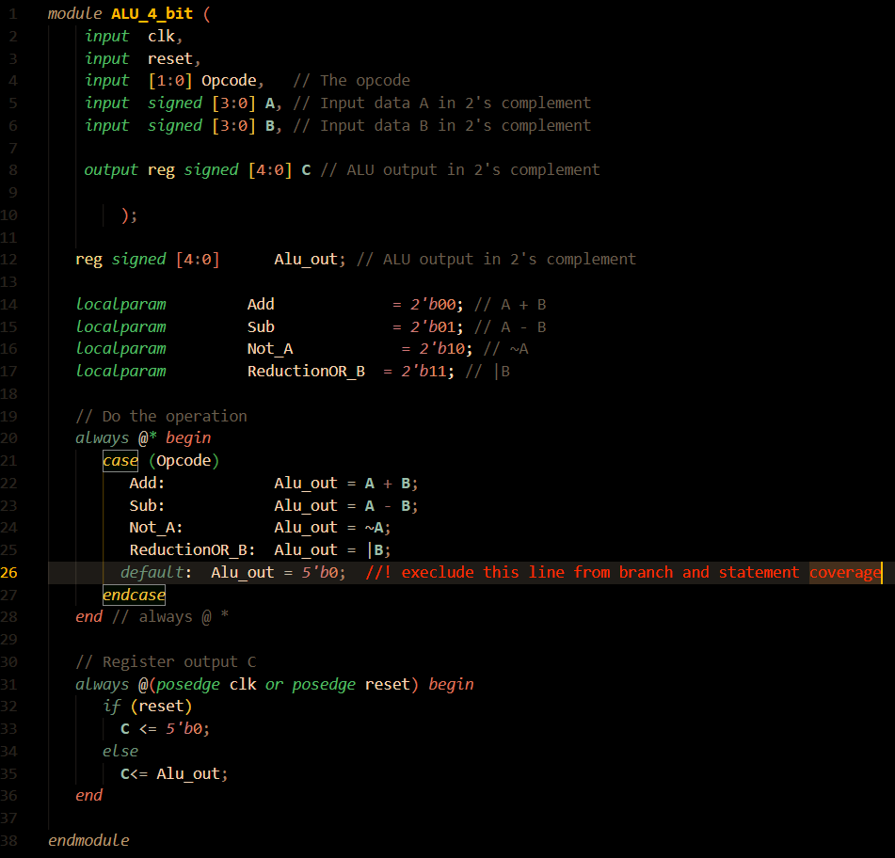
Design is ok. No bugs reported. The default line will be excluded from branch and statement coverage to achieve 100% coverage.

Verification plan

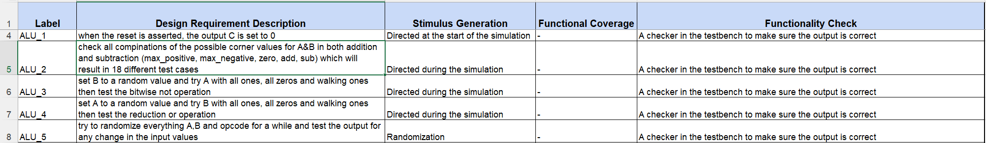

Testbench
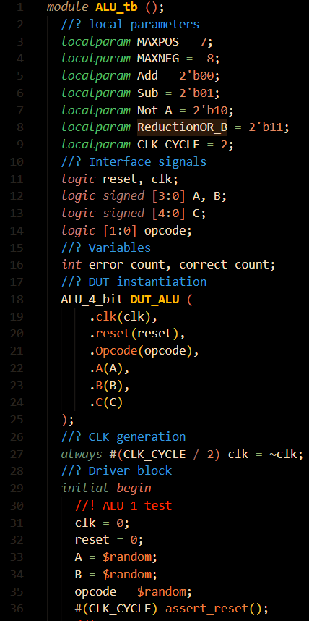

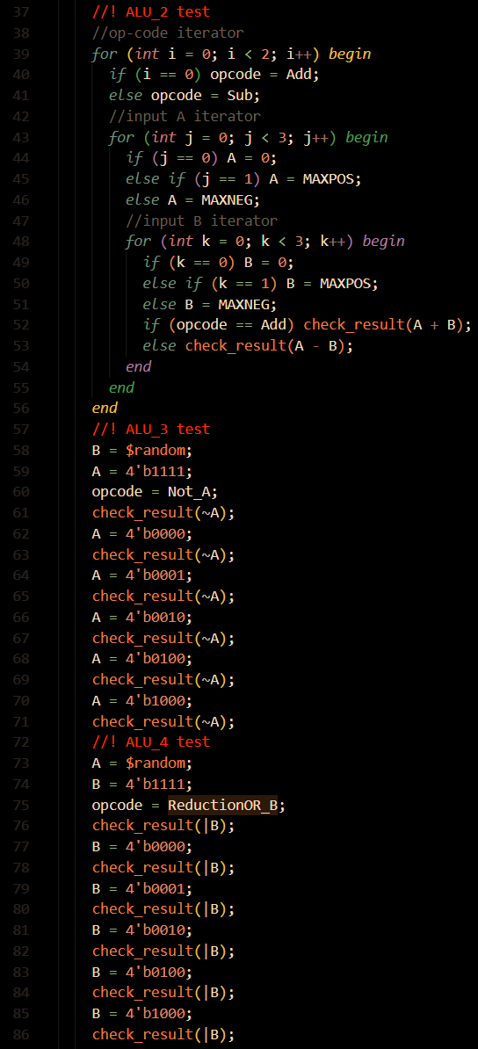

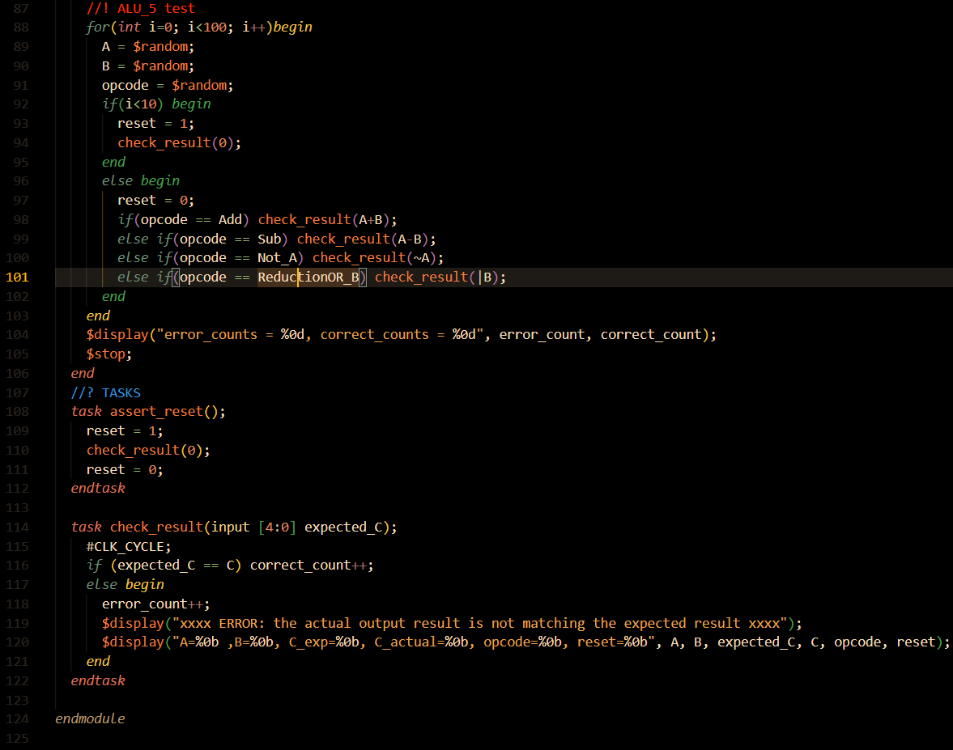

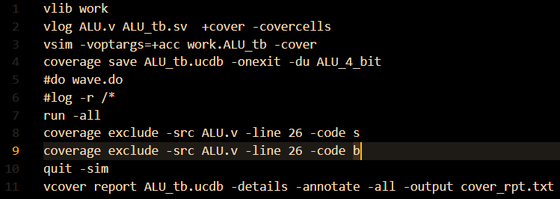
DO file

Simulation results

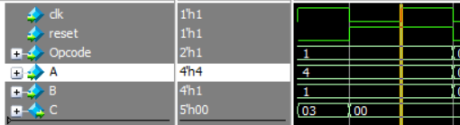
ALU_1 test

ALU_2 test (addition)

ALU_2 test (subtraction)
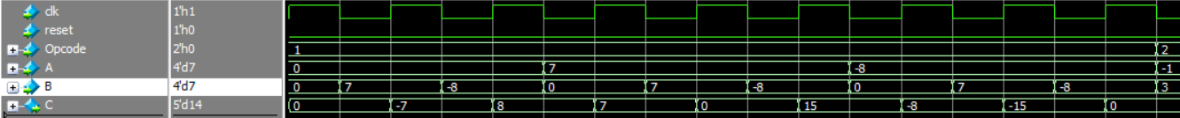

ALU_2 test (bitwise not)

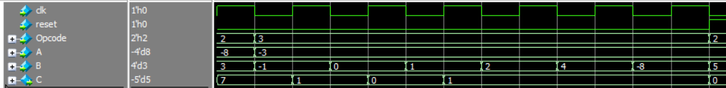
ALU_2 test (reduction or)

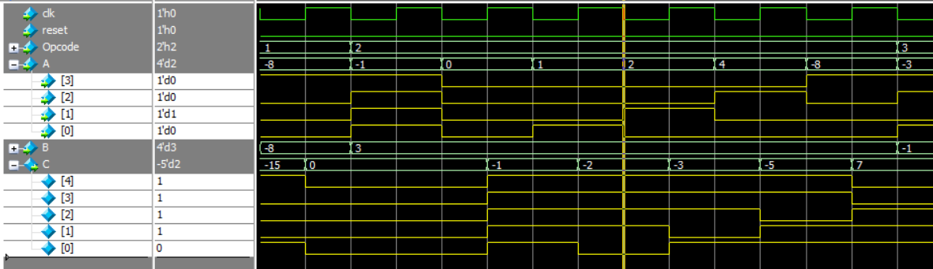
ALU_3 test

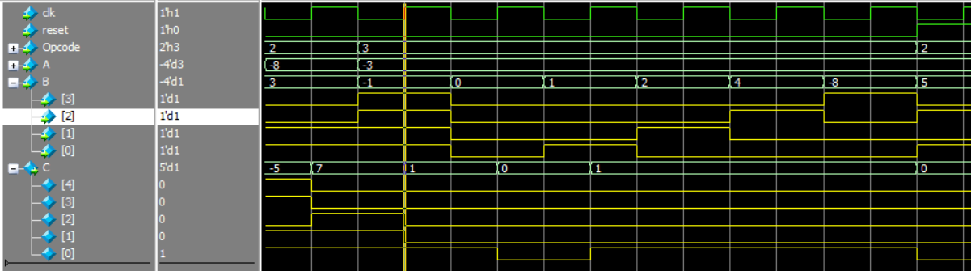
ALU_4 test

ALU_5 test

Coverage report

Branch coverage
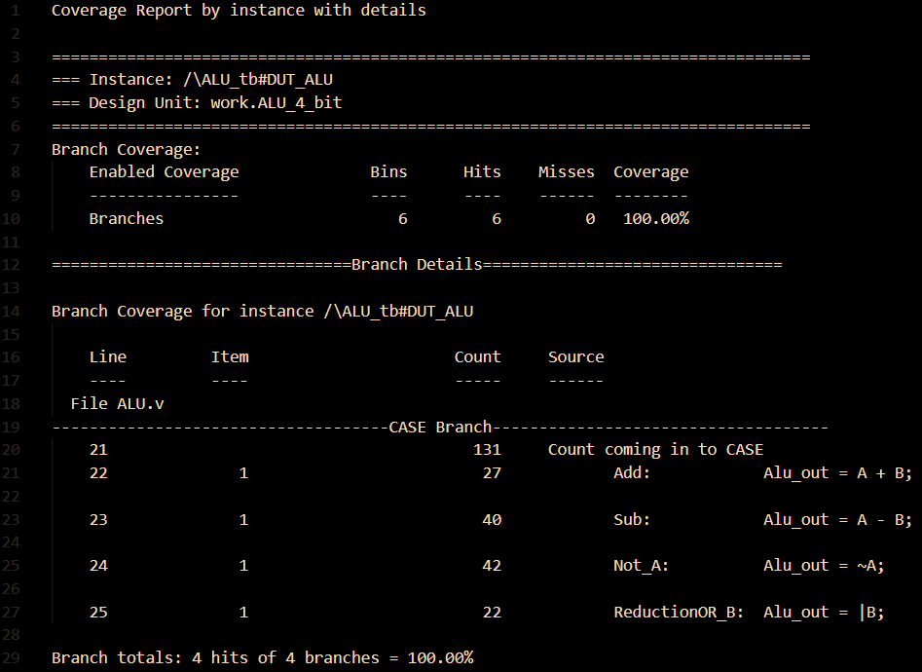

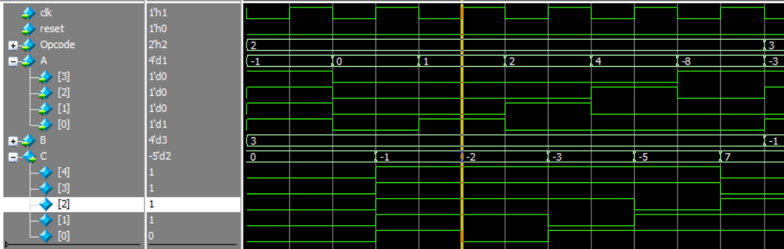

Statement coverage
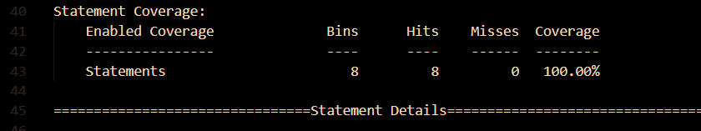

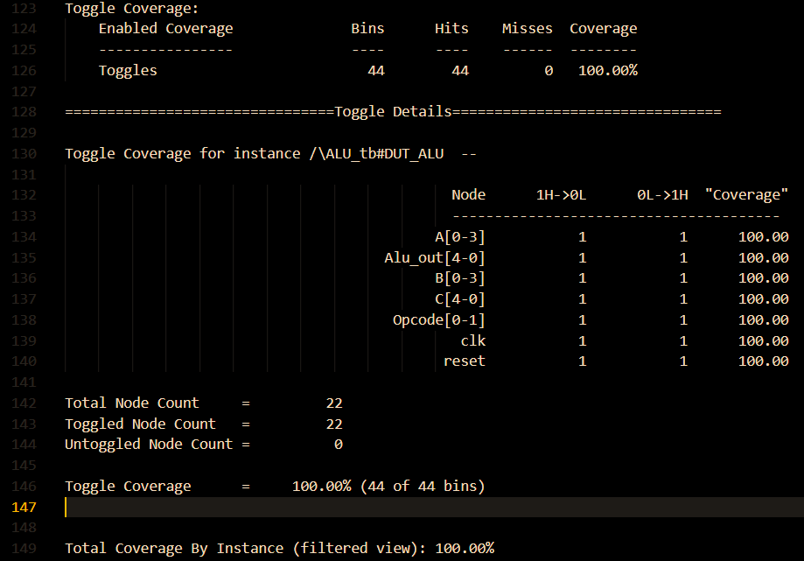
Toggle coverage

DSP

Design
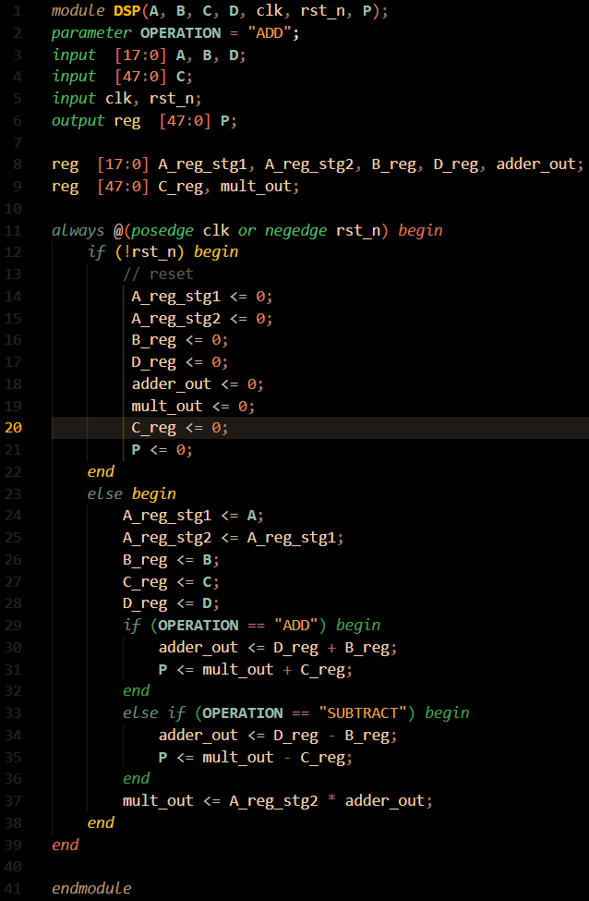
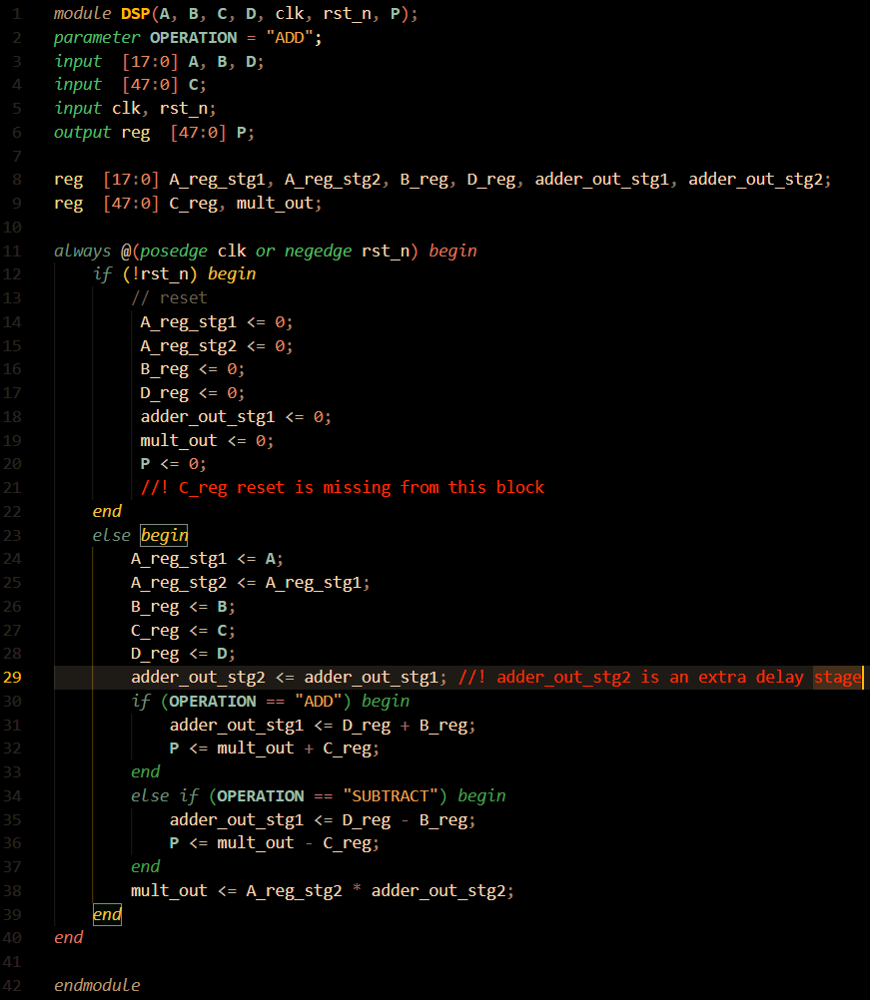
The design has two bugs, C_reg doesn't have a reset signal, there is an extra stage in the adder pipeline path which is incorrect and will cause an extra delay cycle.

Verification plan

Testbench
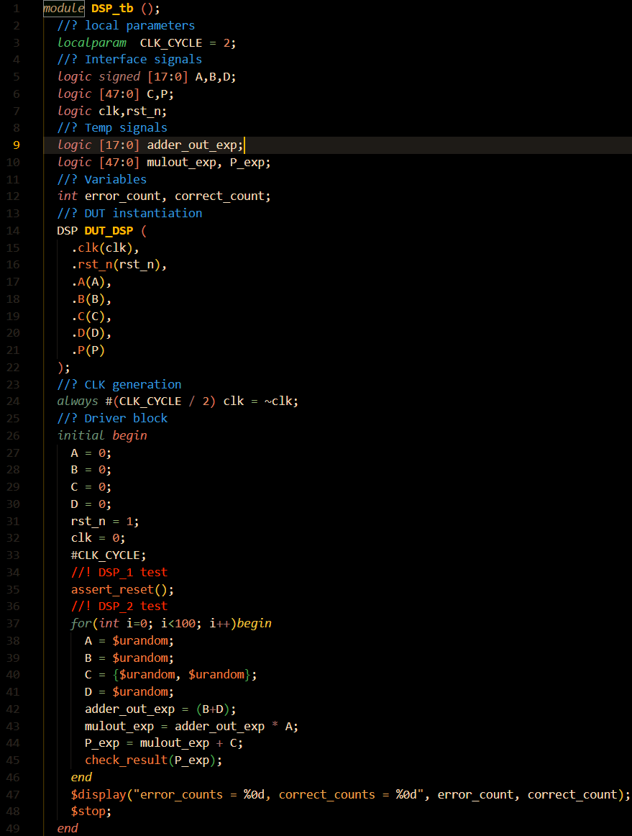

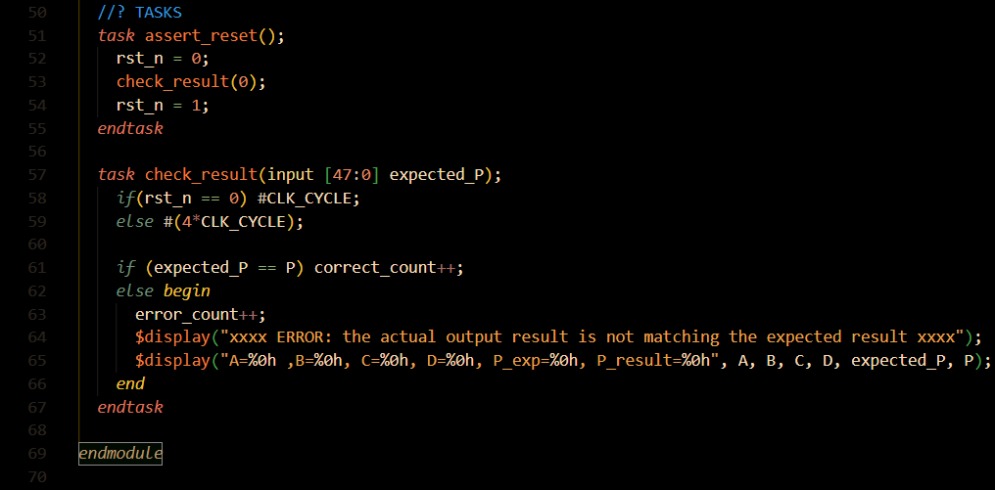

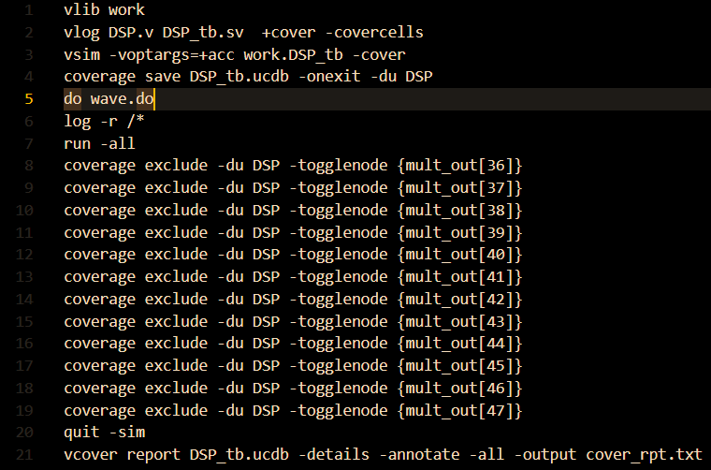
DO file

Simulation results

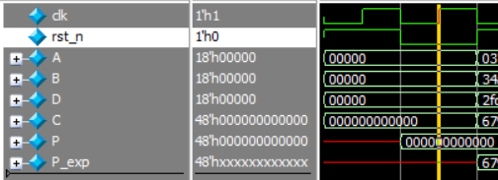
DSP_1 test

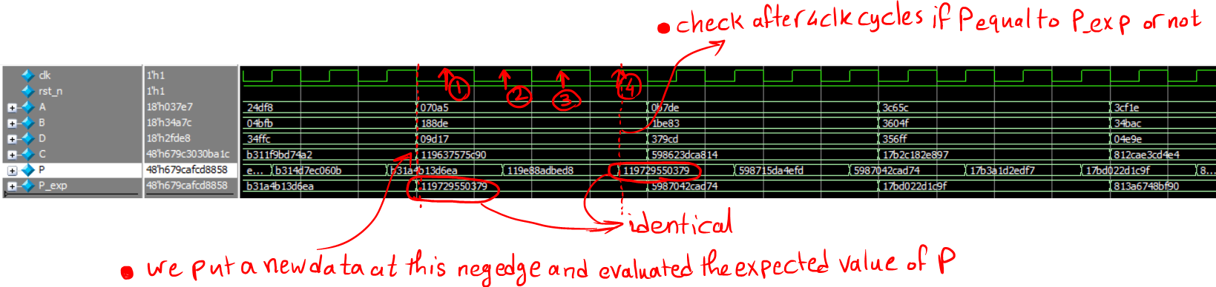
DSP_2 test

Coverage report

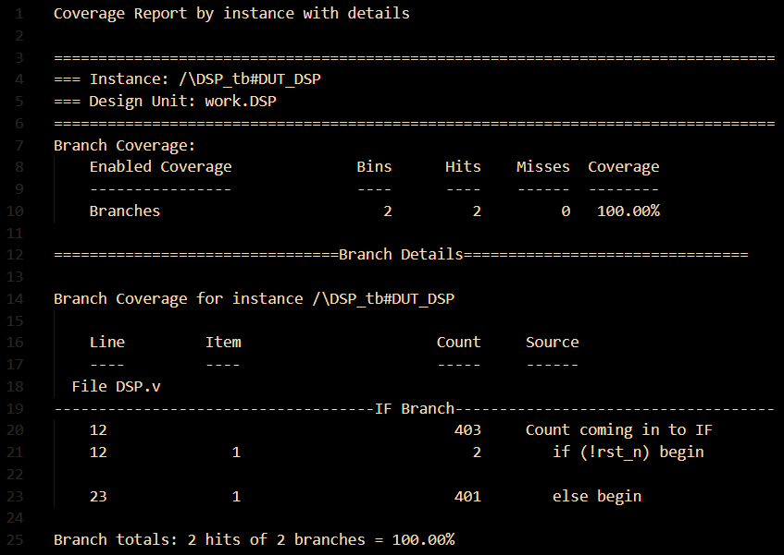
branch coverage

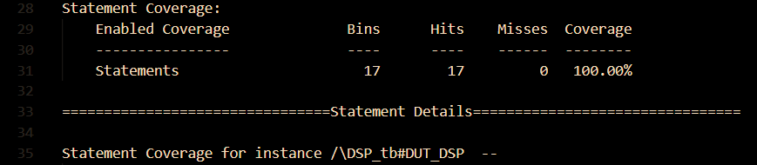
Statement coverage

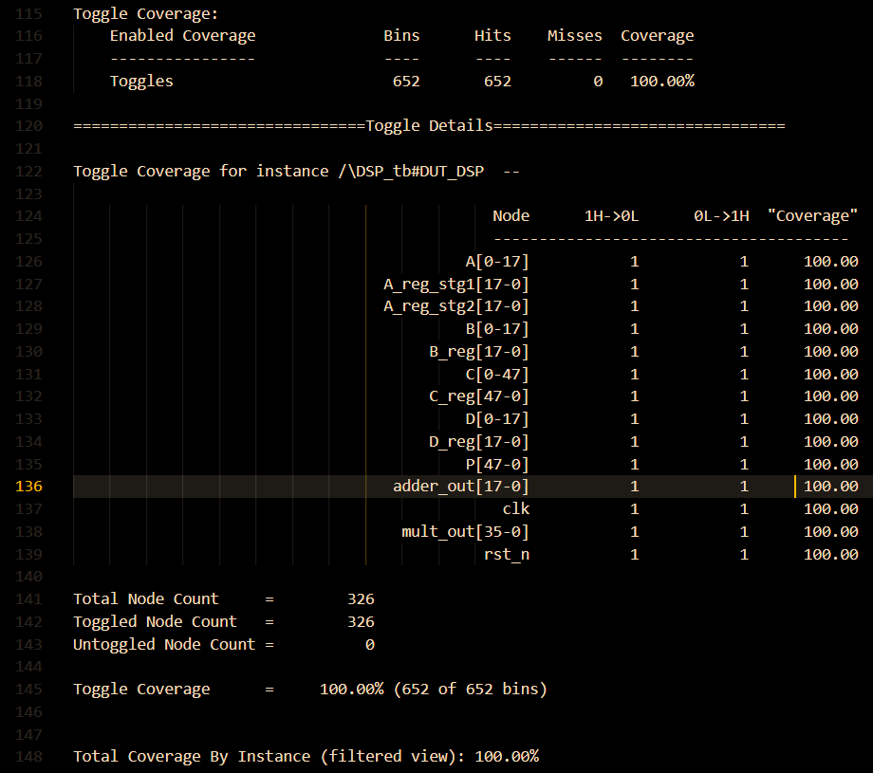
Toggle coverage

